Thoughts from your President, Maxine Paul
I think one of the least exciting aspects of my role as Diocesan President is that I am a co-opted member of Diocesan Synod. It is, however, proving to be extremely interesting both from the point of view of gaining an insight into the way the Diocese is moving forward, so we can keep in step, but also, to provide an opportunity for me to give a Mothers’ Union perspective to discussions.
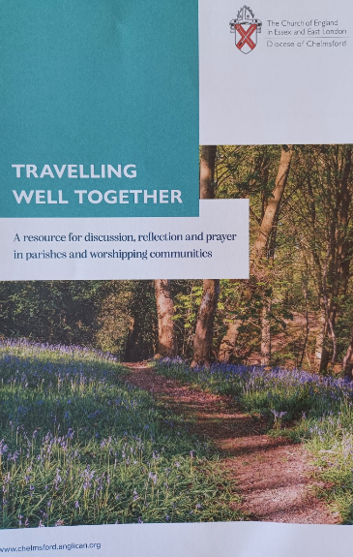
Bishop Guli is currently inviting parishes and worshipping communities (I think we qualify as quite a large worshipping community) within the diocese to use a resource entitled “Travelling Well Together” for discussion, reflection and prayer. Whilst it isn’t quite the same as Re-imagining MU, it is a different sort of way for the diocese to journey together into the future. It isn’t an initiative as such, but a new approach to build on what has gone before through discussion in groups and parishes particularly using seven core values to frame how we travel well together.
Your church may have been looking at it during Lent or have ordered copies for distribution. If not, I do encourage you to have a look at the material online at https://www.chelmsford.anglican.org/travelling-well-together-lent-course-2023-introduction
As I write, we have already travelled over halfway through Lent and when you read this, we will be just days away from Holy Week. It would be interesting to hear how you have been using the MU Family Lent Calendar (with pictures) for Roundabout or have your comments on using Metamorphosis Bite-size.
As we follow Christ’s journey to the cross, I pray that we all know the blessed assurance that as He died on that cross and then rose again to glory, so we also will rise again in glory with Him one day.
With my love and prayers for a joyous and glorious Easter.
Maxine x

Mothering Sunday
A big thank you to all members who have supported this year’s Make a Mother’s Day campaign, giving a Gift of Perseverance to support and empower women around the world. You may be interested to know that the prayers from 19-25th March in the Prayer Diary, including for Mothering Sunday, were written by our former DP Judith Meaden. Thank you to Judith for contributing these beautiful prayers.

Campaign updates
In March, Mothers’ Union was promoting the International Women’s Day campaign which this year is all about embracing equity. The video Mothers’ Union has created in support of this worldwide campaign is available to view on the central website: International Women's Day 2023 | Mothers' Union (mothersunion.org) #EmbraceEquity

On 6th February Mothers’ Union marked the International Day of Zero Tolerance to Female Genital Mutilation with an important article on the central website. You can read more about the crucial work Mothers’ Union members are doing in Tanzania to tackle FGM and child marriage here: How Mothers' Union is helping to tackle FGM and child marriage | Mothers' Union (mothersunion.org)

Metamorphosis bitesize
MSH are holding the last Zoom session on Metamorphosis bite-size on Tuesday 11th April at 2pm. Please contact development@mothersunion.org for further details. This is the last planned Zoom session but if there is further demand MSH will consider holding further sessions.

May Council
May Council will take place in the Chapter House on 24th May (7pm for 7:30pm) when we are due to hear more from Phillis about the Epping Thrive Domestic Abuse Survivors Support group. Please contact our diocesan secretary to let us know if you or any of your members are planning to attend. secretary@muchelmsford.org.uk

Thy Kingdom Come 2023
Thy Kingdom Come preparations are officially underway for 2023. Rather than producing an online service, MSH are encouraging members to hold events in their local areas and involve both their own church and other local churches. Resources are available to download at www.mothersunion.org/news/thy-kingdom-come-2023-0

News from Mary Sumner House
The monthly Indoor Members Prayer Circle reflection is attached to this newsletter.

Copies of the Easter and Spring/Summer 2023 Gift Guide are still available to order from the MUe online shop: www.mueshop.org

Tackling sexual harassment – The ‘Bystander’ Initiative
Essex County Council has recently launched a new initiative that aims to address sexual harassment and inappropriate behaviour towards women and girls. The ‘Bystander Intervention’ initiative aims to provide residents with information and guidance on what they could do if they see inappropriate or threatening behaviour and gives advice on how they could address it in a safe way. There is also an online module with a focus on women’s safety and sexual harassment. Visit www.essex.gov.uk/bystander.

Diocesan fundraising concert
On 7th October, Emmanuel Church Billericay will be hosting a concert by the acclaimed cello and piano electronics duo Two Lads and a Laptop. The concert will be raising funds for English for Women. Tickets are priced at £15 and will be available at May Council.

Dates for the dairy

- Thy Kingdom Come: 18th – 28th May
- May Council: evening of 24th May in the Chapter House, 7pm for 7:30pm
- Tickets for the Annual Gathering in York on Friday 22nd September now on sale: https://www.mothersunion.org/annual-gathering-2023
- Two Lads and a Laptop concert: 7th October 7pm Emmanuel Church, Billericay.

